XMT®
350 Series
Issued Nov. 2019 • Index No. DC/18.93


Multiprocess Welding
Power Source

Quick Specs
Heavy Industrial Applications
Construction Shipbuilding Railroad
Truck/trailer manufacturing Fabrication
Repair shops Rental fleets
Power generation plants
Processes
MIG (GMAW)/Pulsed MIG (GMAW-P)*
Stick (SMAW) TIG (GTAW)
Flux-cored (FCAW)
Air carbon arc cutting and gouging (CAC-A) Rated: 1/4-inch carbons
Capable: 5/16-inch carbons
*Available on select models.
Input Power Auto-Line™, 208 – 575 V,
requires 3- or 1-phase power
Output Range 10 – 38 V, 15 – 425 A
Net Weight 80 lb. (36.3 kg)
Auxiliary Power (optional)
120 V, 10 amps

Portability and excellent arc performance make the XMT family the most popular in the industry.
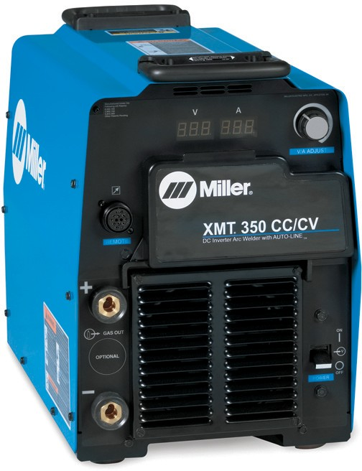
With multiprocess capabilities and features like Auto-Line, the XMT 350 is portable and versatile for applications from jobsites to the factory floor.



AUTO-LINE™

Input power management for portability


CONVENIENT
HANDLES
LESS SPACE
Lightweight and portable


WELDS
WITH LESS
REWORK
BETTER

XMT 350 CC/CV shown
Best multiprocess capabilities



Power source is warranted for three years, parts and labor. Original main power rectifier parts are warranted for five years.

Miller Electric Mfg. LLC
An ITW Welding Company 1635 West Spencer Street
P.O. Box 1079
Appleton, WI 54912-1079 USA

Equipment Sales US and Canada
Phone: 866-931-9730
FAX: 800-637-2315
International Phone: 920-735-4554
International FAX: 920-735-4125

MillerWelds.com



XMT 350 CC/CV
XMT 350 MPa
Choosing the Correct XMT® 350
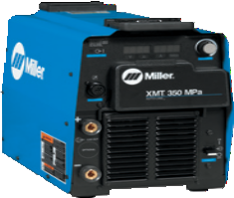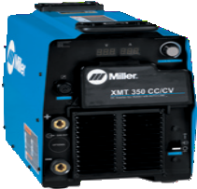
MOST POPULAR!
XMT 350 CC/CV
Flexibility and simplicity make this the most popular model. It has the core multiprocess capabilities along with the flexibility of a 14-pin for spool guns, feeders, and remote controls.
XMT 350 MPa
Built-in pulse programs for manufacturing and fabrication applications that have benefits for standard steels, high-strength steels and aluminum.

Input Power |  | Auto-Line™ 208 – 575 V, 3- or -1-phase
Input Voltage Limits |  | 190 – 630 V
Weld Output |  | 350 A at 34 VDC, 60% duty cycle
Carbon Arc Gouging |  | Rated: 1/4-inch carbons, Capable: 5/16-inch carbons
Net Weight |  | 80 lb. (36.3 kg)
Output Connections |  | Dinse-style
Stick/TIG/MIG
Pulsed MIG
Compatible Accessories | Insight Core™
Compatible Accessories | ArcReach® SuitCase® Feeders
Compatible Accessories | Bench Feeders
Compatible Accessories | Spool Guns
Compatible Accessories | Remote Controls

XMT® 350 Series Features

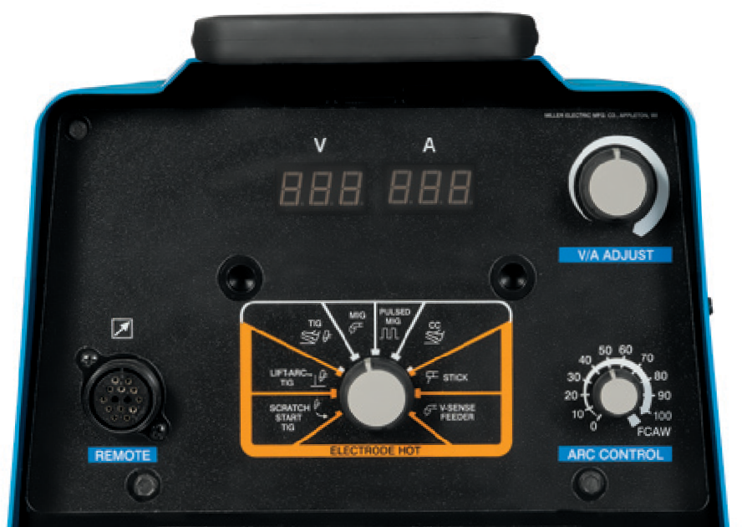Versatility

For portability and reliability, Auto-Line allows for any input voltage hookup
(208 – 575 V, single- or three-phase) with no manual linking, providing convenience in any job setting. Ideal solution for dirty or unreliable input power.
14-pin receptacle has the flexibility to be used with spool guns, feeders, and remote controls.
Optional 115-volt auxiliary power provides 10 amps of circuit-breaker- protected power for coolant systems, etc.


Optional Welding Intelligence™ system.
XMT CC/CV and MPa models are Insight-capable to monitor weld voltage, amperage, and arc-time and percentage.

Multiprocess weld quality
High-quality performance in all welding processes.
Adaptive Hot Start™ makes starting stick electrodes easy without creating an inclusion.
Infinite arc control available in the stick and wire modes for easier fine tuning of tough-to-weld materials and out-of-position applications.
Lift-Arc™ provides arc starting that minimizes contamination of the electrode and without the use of high-frequency.

XMT 350 CC/CV panel shown

Reliability
Wind Tunnel Technology.™ Internal air flow that protects electrical components and PC boards from dirt, dust and debris… greatly improving reliability.
Fan-On-Demand™ cooling system operates only when needed, reducing noise, energy use and the amount of contaminants pulled through machine.
Lightweight aerospace-grade aluminum case offers protection with the benefit of reduced weight.
Dinse-style weld disconnects provide high-quality weld cable connections.
Note: Two Dinse-style connectors are supplied with each Dinse machine.

Welder friendly control panel
Process selector switch reduces the number of control setup combinations without reducing any features.
Large, dual digital meters are easy to view and are presettable to ease setting weld output.
Ultra-tough, polycarbonate-blended cover protects front controls from damage.
Primary voltage display shows what primary voltage the power source is linked for without removing the side panels. Saves time and assures you that the power source has been correctly linked for available input voltage.
Auto Remote Sense™ enables unit to automatically use remote control if connected to remote control receptacle.

Portability
Jobsite mobility is made easy with a small, compact design and Auto-Line technology.

Additional XMT® 350 MPa Features

Built-in pulse programs for manufacturing and fabrication applications that have benefits for standard steels, high-strength steels and aluminum.

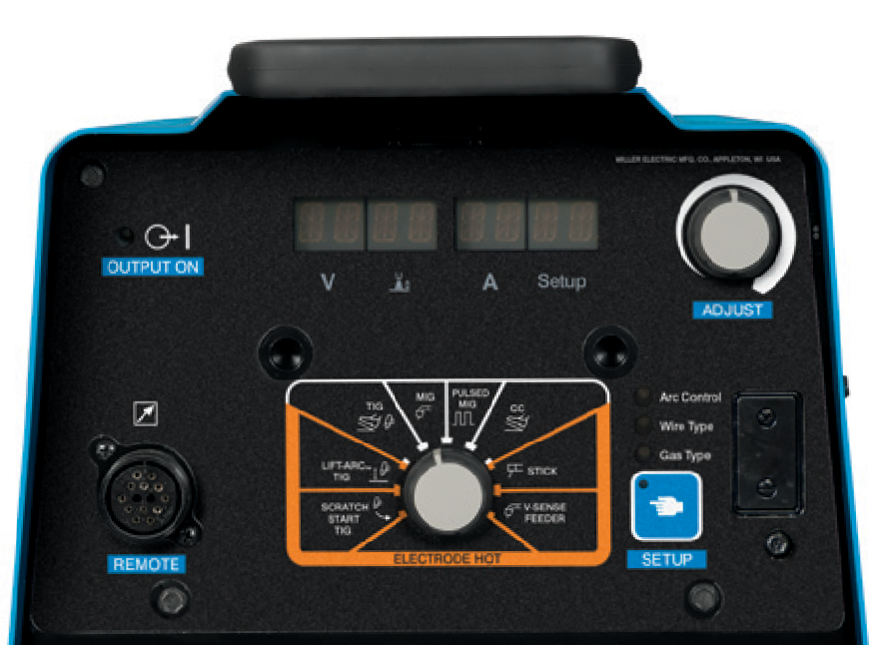Setup indicator lights
- Arc control indicator
- Wire type indicator
- Gas type indicator
- Setup button

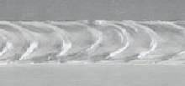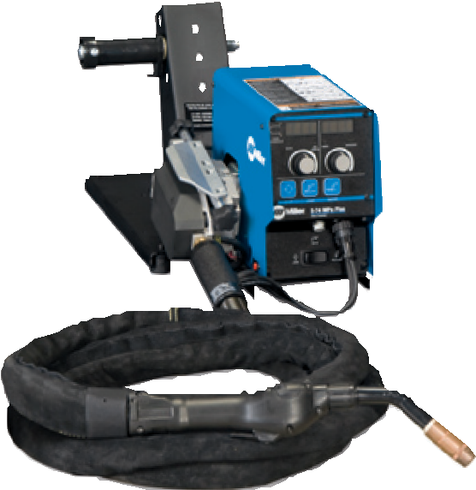Advanced arc control enables an improved pulse welding arc. The operator has more control over puddle and bead characteristics using SharpArc.. In addition, the unit provides a more robust and stable arc at very low arc length, reducing heat input, and providing the ability to weld on a wider range of material thickness.
Additional features when using a 70 Series MPa Plus feeder or XR-AlumaFeed® feeder.
Synergic pulsed MIG. As you increase/ decrease the wire feed speed, the pulse parameters increase/decrease, matching the right amount of power output to match the wire speed, eliminating the need to make additional adjustments.
Profile Pulse™ provides TIG appearance with MIG simplicity
and productivity. Achieve “stacked dimes” without gun manipulation. Profile Pulse frequency can be changed to increase or decrease the spacing between the ripple pattern to achieve the desired weld appearance.
Added capabilities with Insight Core.™ When using an MPa Plus feeder, wire deposition is added to the Insight Core capabilities.
SharpArc® controls the arc in pulsed MIG mode and gives total control over the arc cone shape, puddle fluidity and bead profile. If a gas is used other than what is listed in the chart above, SharpArc can be
(0 setting)
(50 setting)

adjusted to help customize your arc to the gas being
Low Setting High Setting

used. Lower SharpArc settings widen the arc cone, increase puddle fluidity and flattens the weld bead.
Built-in pulsed MIG programs provide reduced heat affected zone, weld in all positions, great for thick-to-thin metal, good gap filling ability and faster travel speeds and deposition. See the table below for the wide range of pulsed MIG (GMAW-P) welding applications the XMT MPa models can handle.

Wire Types — diameter in inches (mm) |  | Gas Types
Steel | .035 (0.9) STL  .045 (1.2) STL | ARGN CO₂ (argon/carbon dioxide)  80 ARGN CO₂ (argon/carbon dioxide) ARGN OXY (argon/oxygen)
Steel 100S | .035 (0.9) STL, .045 (1.2) STL | 100S C5 (95 argon/5 carbon dioxide)
Metal Core | .045 (1.2) MCOR, .052 (1.4) MCOR | ARGN CO₂ (argon/carbon dioxide)
Stainless Steel | .035 (0.9) SSTL  .045 (1.2) SSTL | TRI MIX (tri-gas mixture) ARGN OXY (argon/oxygen)  ARGN CO₂ (argon/carbon dioxide)
Aluminum | .035 (0.9) AL4X (4000 Series)  .040 (1.0) AL4X (4000 Series)  3/64 (1.2) AL4X (4000 Series)  1/16 (1.6) AL4X (4000 Series) | ARGN (argon)
Aluminum | .035 (0.9) AL49 (4943)  .040 (1.0) AL49 (4943)  3/64 (1.2) AL49 (4943)  1/16 (1.6) AL49 (4943) | ARGN (argon)
Aluminum | .035 (0.9) AL5X (5000 Series)  .040 (1.0) AL5X (5000 Series)  3/64 (1.2) AL5X (5000 Series)  1/16 (1.6) AL5X (5000 Series) | ARGN (argon)  HE AR25 (helium/argon)
Nickel | .035 (0.9) NI  .045 (1.2) NI | ARGN HE (argon/helium) ARGN (argon)
Copper Nickel | .035 (0.9) CUNI, .045 (1.2) CUNI | HE ARGN (helium/argon)
Silicon Bronze | .035 (0.9) SIBR, .045 (1.2) SIBR | ARGN (argon)
Titanium | .035 (0.9) TI-5, .045 (1.2) TI-5 | ARGN HE25 (75 argon/25 helium)
Titanium | .035 (0.9) TI-5, .045 (1.2) TI-5 | ARGN HE50 (50 argon/50 helium)


Specifications (Subject to change without notice.)

Input Power | Voltage Range in CV Mode | Amperage Range in CC Mode | Rated Output | Amps Input at Rated Load Output, 60 Hz  208 V 230 V 400 V 460 V 575 V KVA KW |  |  |  |  |  |  | Max. Open- Circuit Voltage | Dimensions | Net Weight
Three-phase | 10 – 38 V | 5 – 425 A | 350 A at 34 VDC,  60% duty cycle | 40.4 | 36.1 | 20.6 | 17.8 | 14.1 | 14.2 | 13.6 | 75 VDC | H: 17 in. (432 mm)  W: 12.5 in. (318 mm)  D: 24 in. (610 mm) | 80 lb.  (36.3 kg)
Single-phase | 10 – 38 V | 5 – 425 A | 300 A at 32 VDC,  60% duty cycle | 60.8 | 54.6 | 29.7 | 24.5 | 19.9 | 11.7 | 11.2 | 75 VDC | H: 17 in. (432 mm)  W: 12.5 in. (318 mm)  D: 24 in. (610 mm) | 80 lb.  (36.3 kg)

Certified by Canadian Standards Association to both the Canadian and U.S. Standards.

Performance Data

Duty Cycle Chart
500
3-ph | ase operatio | n
1-ph | ase operatio | n
 |  |  |  | 6 AW | G power | cord
 |  |  |  | 8 AW  (supp | G power lied with | cord power | source)

425
400
350

300
Welding Amperes

250

200

150

100
10 15 20 25 30

40 50 60 70

80 90 100

% Duty Cycle

Genuine Miller® Accessories

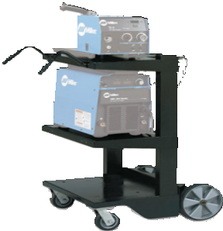
Remote Controls

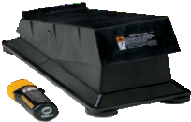

Wireless Remote Foot Control 300429 For remote current and contactor control.
Receiver plugs directly into the 14-pin receptacle
of Miller machine.

Extension Cables for Remote Controls and 24 VAC Wire Feeders
242208025 25 ft. (7.6 m)
242208050 50 ft. (15 m)
242208080 80 ft. (24.3 m)
14-pin plug to 14-pin socket. Not for use with XR-AlumaFeed® or 70 Series MPa feeder.

MIGRunner™ Cart
195445 For single feeders
Small footprint and easily maneuverable, with dual-cylinder rack low enough that you do not have to lift bottles. Durable ergonomic handles are designed for comfort.
Note: Not compatible with dual wire feeders.
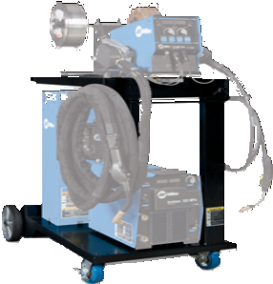
Running Gear Cylinder Rack 300408 For single or dual feeders
Holds two large gas cylinders and has gun cable hangers and a consumable drawer in front. A convenient handle allows the cart to be pulled easily through doorways. Power source and single or dual feeders can be mounted to cart and secured.
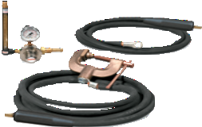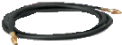

MIG kit 300405
shown.
Industrial MIG 4/0 Kit with Dinse Connectors 300405 For single feeders
300956 For dual feeders
Consists of flowmeter regulator with 10-foot (3 m) gas hose, 10-foot (3 m) 4/0 feeder weld cable, and 15-foot (4.6 m) work cable with 600-amp C-clamp. Dual kit comes with two flowmeter regulators and gas hoses.
90-foot (27.4 m) operating range.

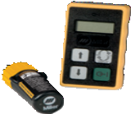
Wireless Remote
Hand Control 300430
For remote current and contactor control.
Receiver plugs directly into the 14-pin receptacle of Miller machine.
300-foot (91.4 m) operating range.

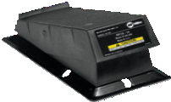
RFCS-14 HD Foot
Control 194744 Maximum flexibility is accomplished with a reconfigurable cord that can exit the front, back
or either side of the pedal. Foot pedal provides remote current and contactor control. Includes 20-foot (6 m) cord and 14-pin plug.

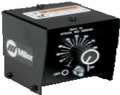
RHC-14 Hand Control 242211020
20-foot (6 m) cord

242211100
100-foot (30.5 m) cord Miniature hand control for remote current and
contactor control. Dimensions: 4 x 4 x 3.25
inches (102 x 102 x 82 mm). Includes cord and 14-pin plug.
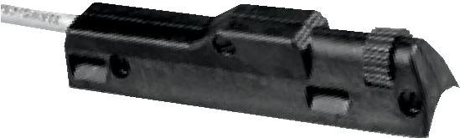

RCC-14 Remote Contactor and Current Control 151086
East/west rotary-motion fingertip control attaches to TIG torch using two hook-and-loop fasteners. Includes 26.5-foot (8 m) cord and 14-pin plug.
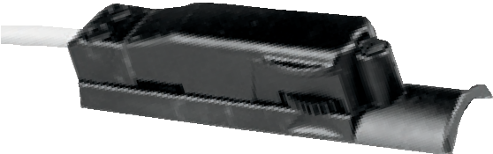

RCCS-14 Remote Contactor and Current Control 043688
North/south rotary-motion fingertip control attaches to TIG torch using two hook-and-loop fasteners. Includes 26.5-foot (8 m) cord and 14-pin plug.

Cable Connectors and Adapters

Note: XMT 350 power sources are equipped with Dinse-style connectors for secondary connections.

Dinse-Style Connectors
042418 Accepts #4 to #1/0 AWG cable 042533 Accepts #1/0 to #2/0 AWG cable Kits include one Dinse-style male plug which attaches to the work and/or weld cables and plugs into the Dinse-style receptacles on the power source.

Extension Kit for Dinse-Style Cable Connectors 042419 Accepts #4 to #1/0 AWG cable.
Used to adapt or extend weld and/or work cables. Kit includes one male Dinse-style plug and one in-line female Dinse-style receptacle.

Extensions for Dinse-Style Cable Connectors 134460 Male Dinse-style plug
136600 Female Dinse-style receptacle Used to adapt or extend weld and/or work cables. Accepts #1/0 to #2/0 AWG cable.

Dinse/Tweco® Adapter 042465
Dinse/Cam-Lok Adapter 042466
One-piece adapter with Dinse-style male plug (to power source) on one end and Tweco or Cam-Lok female receptacle (for weld cable connection) on other end.

Wire Feeders/Guns

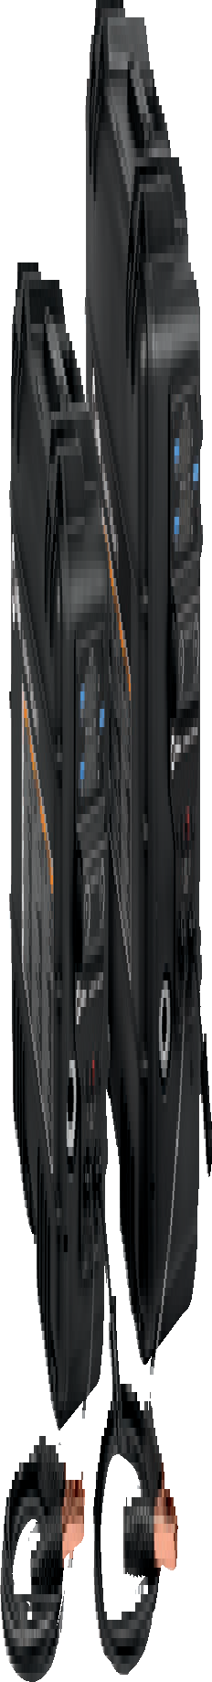
ArcReach® SuitCase® 8
951726 With Bernard® BTB Gun 300 A 951728 With Bernard® Dura-Flux™ gun ArcReach® SuitCase® 12
951729 With Bernard® BTB Gun 300 A
951731 With Bernard® Dura-Flux™ gun
Portable feeder designed to run off of arc voltage. When paired with an ArcReach power source, provides remote control of the power source without a control cord — saving time and money. See literature M/6.55.
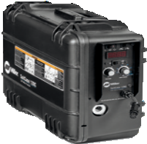

SuitCase® 12RC 951580
Lightweight, portable wire feeder for a variety of wires up to .062 inch. Holds up to a 12-inch (12RC) spool of wire. Includes remote voltage control, drive roll kit and Bernard® BTB Gun 300 A. See literature M/6.5.
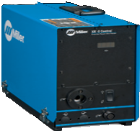

XR™-S Control 300601
Controls offer unsurpassed performance and reliability for feeding aluminum and other difficult-to-feed wire types. Models include
.035-inch and factory-installed 3/64-inch drive rolls. See literature M/1.7.

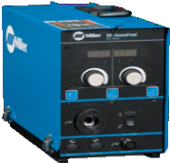

XR-AlumaFeed® 300509
Advanced push-pull wire feeder designed for high-volume, high-production aluminum MIG welding where quality and consistency is a high priority. See literature DC/34.0.
Genuine Miller® Accessories (Continued)
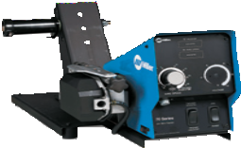

70 Series
S-74S 951196
S-74D 951198
Features Posifeed™ wire drive assembly and handles a variety of wires up to 1/8 inch.
Includes Bernard® BTB Gun 400 A. Dual-wire models also available. See literature M/3.0.
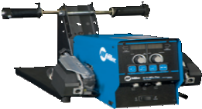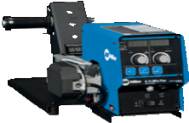

70 Series MPa Plus
S-74 MPa Plus 951291 D-74 MPa Plus 951292
Same features as traditional 70 Series plus more. Handles a variety of wires up to 5/64 inch. Includes Bernard® BTB Gun 400 A. Works synergically with MPa power sources. See literature M/3.0.

Extension Cables 247831025 25 ft. (7.6 m)
247831050 50 ft. (15.2 m)
247831080 80 ft. (24.4 m)
Eleven conductors to support contactor control and remote voltage control on all Miller® electronic CV 14-pin power sources. Additional functions supported when using MPa power sources include synergic pulsed MIG, remote process select and side select capabilities.

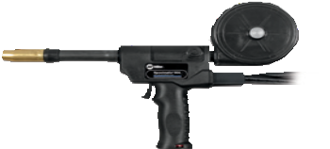

Spoolmatic® 30A 130831
WC-24 (137549) required for use with 14-pin receptacles, order separately. A one-pound, air-cooled spool gun that extends the weld process range by adding a handy portable system for small wire MIG. Rated 200 amps at 100% duty cycle. Includes 30-foot (9.1 m) cable assembly.

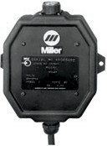
WC-24 Weld Control 137549
Required to use Spoolmatic 30A spool gun. Designed for use with Miller CV power sources with 14-pin receptacles and supplying 24 VAC.

Welding Intelligence™

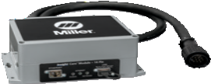

Insight Core™ 14-pin Module 301072
Easy-to-install module brings Insight Core capabilities to your existing fleet. This simplified, Internet-based weld data solution collects, transmits and presents actionable information to any Web-connected device. Insight Core can help you increase productivity, improve weld quality and manage costs.

Ordering Information Most popular models
Power Source and Options Stock No. Description Qty. Price
XMT® 350 CC/CV | 907161  907161011  907161012 | 208 – 575 V with Auto-Line™  208 – 575 V with Auto-Line™ and auxiliary power  230 – 460 V with Auto-Line™ and auxiliary power and CE
XMT® 350 CC/CV MIGRunner™ Packages | 951786  951314 | Power source 907161 with 20 Series Basic feeder Power source 907161 with S-74D feeder  Packages also include MIGRunner cart, Bernard ® BTB Gun, drive roll kit, 10 ft. 2/0 work cable with clamp, 6 ft. 2/0 wire feeder to power source weld cable, and flowmeter regulator with 3 ft. gas hose
XMT® 350 MPa | 907366  907366011  907366002  907366014 | 208 – 575 V with Auto-Line™  208 – 575 V with Auto-Line™ and auxiliary power  230 – 460 V with Auto-Line™ and auxiliary power and CE  208 – 575 V with Auto-Line™ and Tweco® connectors
Gas Valve Kit | 195286 | For XMT 350
Accessories
MIGRunner™ Cart | 195445 | For single feeders
Running Gear Cylinder Rack | 300408 | For dual feeders
Industrial MIG 4/0 Kit with Dinse Connectors | 300405  300956 | For single feeders For dual feeders
Cable Connectors and Adapters |  | See page 6
Remote Controls
Wireless Remote Foot Control | 300429 | Foot control with wireless 90 ft. (27.4 m) operating range
Wireless Remote Hand Control | 300430 | Hand control with wireless 300 ft. (91.4 m) operating range
RFCS-14 HD | 194744 | Foot control with 20 ft. (6 m) cord and 14-pin plug
RHC-14 | 242211020  242211100 | Hand control with 20 ft. (6 m) cord Hand control with 100 ft. (30.5 m) cord
RCC-14 | 151086 | Fingertip control
RCCS-14 | 043688 | Fingertip control
Extension Cables (8-conductor) |  | See page 6
Wire Feeders/Guns
ArcReach® SuitCase® 8 | 951726  951728 | With Bernard® BTB Gun 300 A. See literature M/6.55 With Bernard® Dura-Flux™ gun
ArcReach® SuitCase® 12 | 951729  951731 | With Bernard® BTB Gun 300 A. See literature M/6.55 With Bernard® Dura-Flux™ gun
SuitCase® 12RC | 951580 | With Bernard® BTB Gun 300 A. See literature M/6.5
XR™-S Control | 300601 | Standard model with wire feed speed digital display, jog/purge, run-in control, and trigger hold. See literature M/1.7
XR-AlumaFeed® | 300509 | Advanced model adds Profile Pulse™, synergic control, trigger schedule select, lock capabilities and flow meter. See literature DC/34.0
70 Series | 951196  951198 | S-74S. See literature M/3.0 S-74D. See literature M/3.0
70 Series MPa Plus | 951291  951292 | S-74 MPa (single-wire). Works synergically with MPa power sources D-74 MPa (dual-wire). Works synergically with MPa power sources
Extension Cables (11-conductor) |  | See page 7
Spoolmatic® 30A Spool Gun | 130831 | Requires WC-24 for use with 14-pin receptacles
WC-24 Weld Control | 137549 | Required for use with Spoolmatic® 30A and power sources with 14-pin
Bernard® MIG Guns |  | See Bernard literature SP-BTB
Welding Intelligence |  | See page 7
Date: Total Quoted Price:

Distributed by:

© 2019 Miller Electric Mfg. LLC

